Ideation Phase Empathize and Discover

|  |  |
| --- | --- |
| Date | 22 september 2022 |
| Team ID | PNT2022TMID50978  Team leader:M.Abinaya  Team member :R.Vaitheeswari  Team member J.Chitra  Team member:J.Gayathri |
| Project Name | Nutrition Assistant Application |
| Maximum Marks | 4 marks |

Empathy Map Canvas:

Nutrition Assistant Application

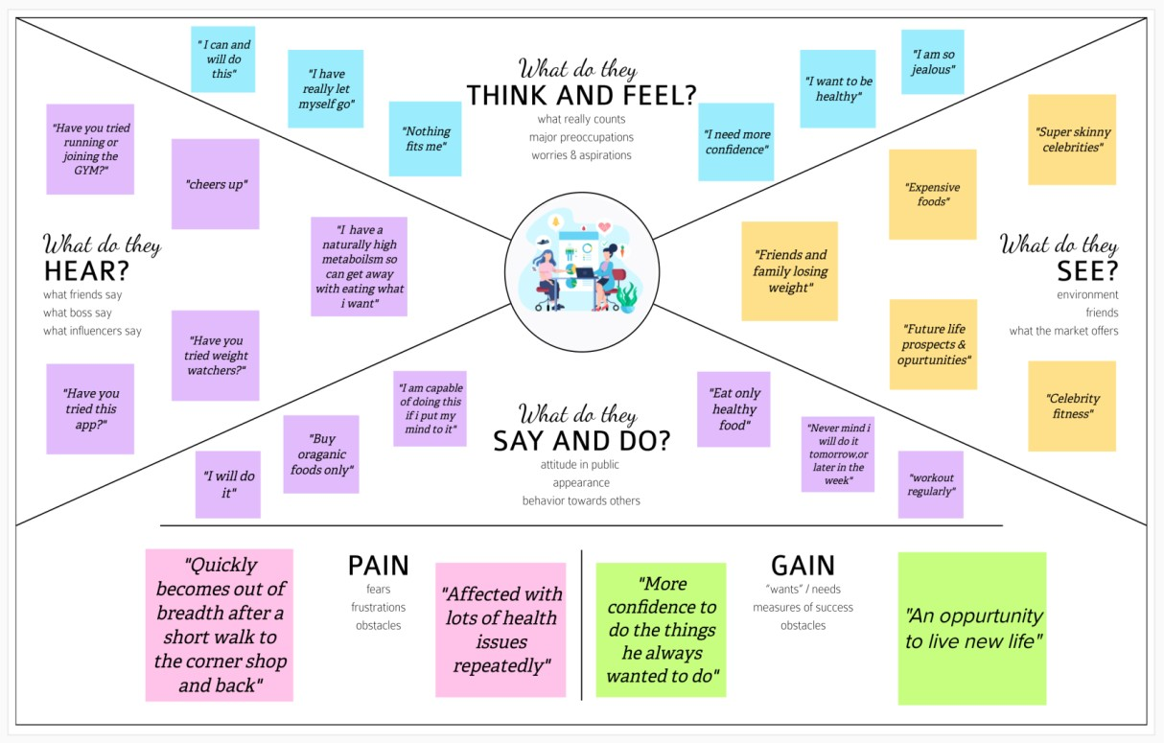

Reference: https://app.mural.co/t/nutritionassistantapplicatio0437/m/nutritionassistantapplicatio0437/166274 0866033/6747adc7cbaa9c9a3c1fe26073ee57687c706efd?wid=0-1553141570911

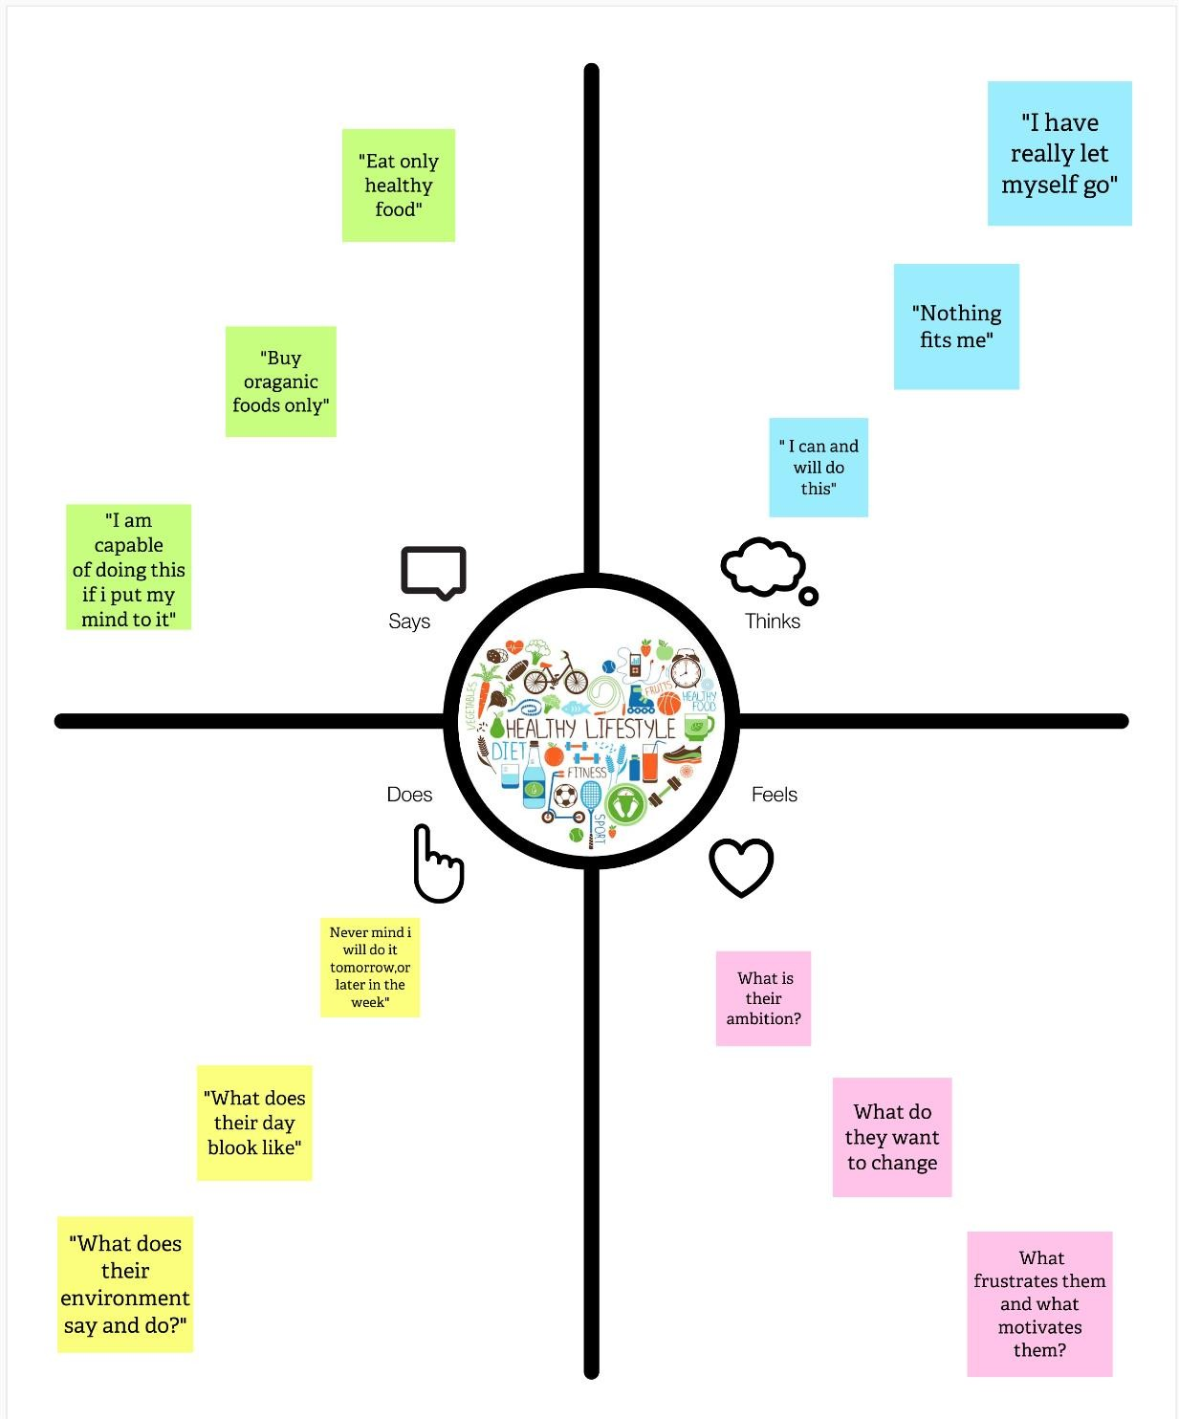

Reference: https://app.mural.co/t/nutritionassistantapplicatio0437/m/nutritionassistantapplicatio0437/166279 1116353/d09f476bcd3a09a2e468ffcef66a6593811c98cd?wid=0-1553138926037